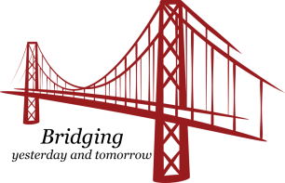
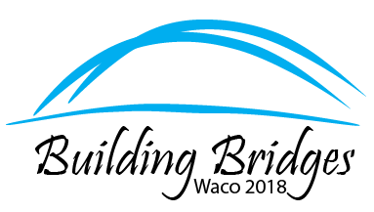
TSO Waco Convention Visual Arts Application

Members are invited to be a part of the Visual Arts Exhibit at the 89th State Convention in Waco.
Application deadline is April 15, 2018.
The exhibit is an opportunity for Texas members to display their best and most creative endeavors.
Art will be on exhibit only and not for sale. The artist will be responsible for preparing her art for display, setting up and taking down. The artist should bring an easel, if needed, since only tables will be provided at the convention. The artist will be able to set up at 10 am Thursday.

If you are interested in sharing your art, please complete the following information and return it to Shirl Hawes by the deadline. The number of displays will be determined by available space.

Name Chapter
Address
Email
Phone Contact Number
Title of Art
Description of Art Piece (watercolor, acrylic, oil, photography, mixed media, digital, colored pencils, pastels, textiles, pottery, ceramics, alcohol ink, acrylic pouring, collage, etc.)

___________________________________________________________________________

Please include a photo of the art to be displayed.
Send completed form to Shirl Hawes shirlhawes@gmail.com
Or mail to Shirl Hawes, PO Box 1076, Mineral Wells, Texas 76068

