STAR³ 2023! FRIENDS, FELLOWSHIP, & FUN!
REGISTRATION
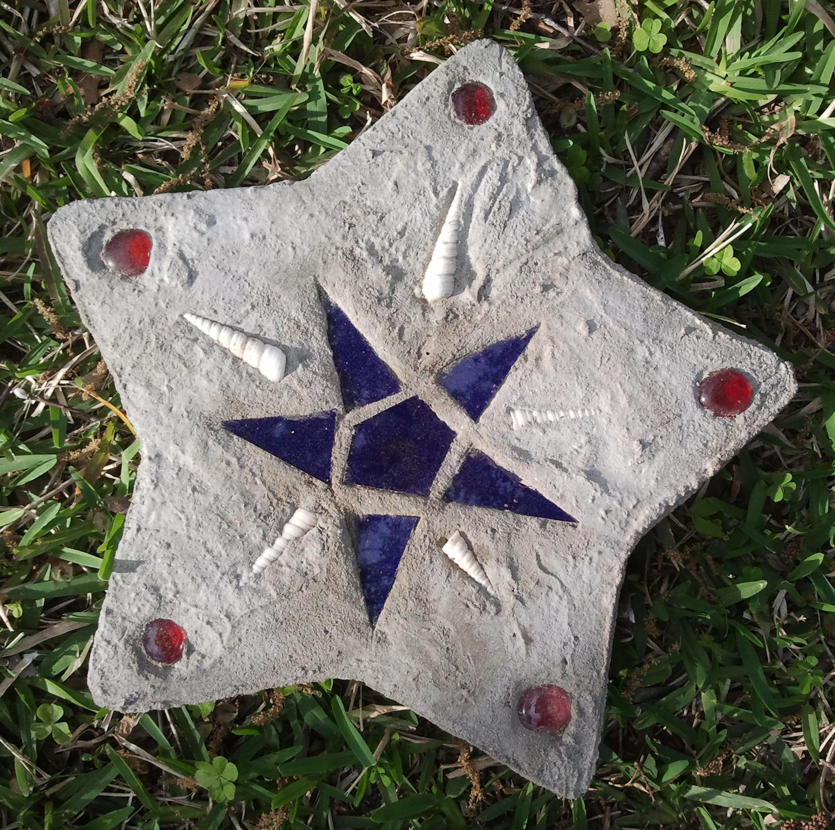

SATURDAY, APRIL 1, 2023
FIRST PRESBYTERIAN CHURCH ~ 1903 Church Street ~ Galveston
8:00 AM TO 3:30 PM
(Space is limited to the first 40 who register)

Last Name ______________________________________ First Name ___________________
Chapter ________________________________________ Area ________________________
Address ___________________________________City ______________Zip _____________
Email _______________________________________________________________________
Home Phone _____________________ Cell Phone __________________Guest ____Y ____N

Breakfast, lunch, and snack will be provided along with all supplies for four Main projects AND four Mini-Crafts. Just bring your scissors and we will take care of the rest. Hope to see you April 1, No Fooling!

Please complete the above information and mail this form along with a check for $30 made payable to Theta Sigma. Please write STAR3 in the memo line.
No Refunds after March 5. Registration closes on March 17.
Mail to:

For information or questions please contact Barbara Derrick at BLSDerrick@aol.com

